The Status of Adolescent Girls in Belize

Results from the
2011 Multiple Indicator Cluster Survey (MICS4)

Population Council UNICEF, Belize
April 2013
Table of Contents
Section 1: Background Notes 3
Foreword 3
Technical Notes 3
Section 2: Introduction 5
Background on Collaboration 5
Why Girls? 5
Section 3: Results from the MICS4 Analysis 6
Urban/Rural Distribution 6
Parental Residence in Household (or Household Composition) 8
Education 10
School Attendance 10
Educational Attainment 17
Class repetition and Grade-for-Age 21
Literacy 26
Time Use 27
Marriage and Relationships 31
Childbearing 34
Sexual Behavior 38
Antenatal Care & Delivery Assistance 39
HIV Testing 41
Attitudes Towards Domestic Violence 44
Section 4: Closing Remarks 48
Conclusions 48
Acknowledgements 48

Section 1: Background Notes

Foreword
The purpose of this report is to provide decision-makers from all sectors - government, UN and civil society – with evidence on the social, demographic, health and economic lives of young people in Belize. While data on boys are presented in the first half of Section 3 the main focus is on girls due to the nature of the collaboration from which this data guide has been born (this is described in Section 2). The tables, charts and maps have been carefully selected to serve as the foundation of a body of empirical evidence to support decisions around the analysis and design of policies; the targeting of resources for programs aimed at specific subgroups within the youth and adolescent population; advocacy campaigns to help mainstream the needs of girls and other vulnerable young people into the policy agenda; and any other initiative aimed at reducing the inequities in access to services and programs experienced by young people of different social, economic and ethnic groups or geographic areas.
The data presented here are meant to inform as well as encourage questions and foster local engagement and action. Ideally, they will serve as the evidence-base for the next generation of adolescent and youth programs and policies more clearly targeted to large, neglected subgroups at critical points in their lifecycle before irreversible, and often tragic, problems arise. In many cases throughout the world, youth policies have failed to channel resources to the more vulnerable and harder-to-reach subgroups of young people and therefore the benefits of these policies have been delivered to the better-off subgroups (typically urban, older, male, unmarried or school-going populations). In most settings, adolescents who are rural, female, younger, out-of-school or married are neglected.
The text that precedes the data in each sub-section frames the data in a way that is appropriate for advocacy groups seeking to raise awareness about the needs of the young and vulnerable people in Belize. The narrative and data are intended for use by policy analysts, program planners and advocates alike to:
- reach conclusions;
- make decisions; and, where the data are unclear or lacking,
- seek clarification through policy and program-oriented research.

Technical Notes
All tables, charts and maps presented in this report are based on data calculated by the authors using the 2011 Belize Multiple Indicator Cluster Survey Round 4 (MICS4), collected by the Statistical Institute of Belize (SIB) with technical and financial support provided by UNICEF. The Belize MICS4 is a nationally representative survey using a sample of 4,417 households and 4,485 individual women between the ages of 15 and 49. Additionally, 3,234 questionnaires on child disability and 1,941 on children under age five were fielded. Data for the Belize MICS4 were collected from June through August, 2011. For a more detailed discussion of the MICS4 refer to the official website at http://www.childinfo.org/mics4.html.
Data in each of the tables, charts and maps have been disaggregated into various groupings to the extent that the data are still representative and considered accurate. Parentheses around a number indicate that the statistic is based on fewer than 50 unweighted cases and data should be considered with caution.
Maps have been selectively included for indicators that show a wide variation between districts. The source of the shapefile used as a base layer for the map is SIB and all data are from the 2011 Belize MICS.
There are a number of clarifications of and limitations with the data presented in this report given the design of the Belize MICS4. These are important to consider when utilizing or presenting the data for any purpose. They are:
- Data on marriage, childbearing, antenatal care, literacy and attitudes towards domestic violence are from the individual women’s questionnaire and therefore do not include females under the age of 15.
- Literacy was only asked of those individual females age 15 to 24 who did not attain any level of secondary education. If a woman had attained any secondary education she was considered literate and therefore not asked to read the literacy test. The data presented in this report separate the two groups so one can get a more detailed perspective on the literacy classifications.
- Ethnicity in the Belize MICS4 was recorded for the household head and not for each individual. Therefore, in the tables and charts presented in this report all disaggregation of indicators by ethnicity is based on the self-reported ethnicity of the household head. It is, therefore, possible that the individuals to whom the data pertain are from a different ethnic group as the household head. As a result, these data should not be considered representative of the particular ethnic group but rather of households headed by an individual from the ethnic group.
- Belize is officially divided into six districts: Belize, Cayo, Corozal, Orange Walk, Stann Creek and Toledo. The MICS4 identified those households in Belize district that fall within the boundary of South Side Belize City as a separate regional classification given the great deal of socio-economic disparity and vulnerability present in this area. This presents a valuable opportunity to highlight specific challenges that young females in South Side Belize City face as they compare to those from other areas. As a result, there are seven total districts used in this report.
The definition of “children,” “adolescents” and “youth” affect many decisions and play an important role in the allocation of resources in a way that has serious budgetary implications for governments, NGOs, UN agencies, civil society groups and donors. For the purpose of this report, the authors chose the definitions adopted by the United Nations. According to the UN’s Department of Economic and Social Affairs, the term “youth” refers to persons between the ages of 15 and 24 while “adolescent” is defined as a person between the ages of 10 and 19. The primary focus of the analysis presented in this report is on the age group of 10-24, encompassing both youth and adolescents, and they are referred to collectively as “young people” throughout this document. While these definitions may or may not correspond to those commonly used for some indicators by government and civil society in Belize, we chose to utilize this standardized definition that is internationally comparable for the purposes of this report.

Section 2: Introduction

Background on Collaboration
The UN Agencies in Belize, under the leadership of UNICEF, recognize the need to expand the number, breadth and capacity of programs serving adolescents – especially girls - in Belize. In order to strengthen both national and district-level responses, a partnership was formed with an international research organization that has a well-established track record of enhancing the well-being of girls across the globe. Through stakeholder-driven research, the Population Council and its national partners have designed and tested context-appropriate asset-building programs for girls in 10 countries around the world. These programs are rooted locally and seek to reach the poorest girls in the poorest communities at an early enough stage in life to head off many of the negative experiences they would otherwise face, and better cope with those they are presented with. Most of these girl programs have become - or are in the process of becoming - institutionalized within existing government and civil society structures, the ultimate goal being sustainability and long-term, multi-generational impact. This document represents one among the first activities undertaken within the Joint UN Program on Strengthening Girls in Belize.

Why Girls?
Young people hold special status as future leaders in every society. How young people’s lives are shaped in the critical years of adolescence determine the direction and magnitude of socio-economic development of their home country for generations to come. The widely confirmed Millennium Development Goals (MDGs) provide a guiding framework for specific actions for improving young people’s lives. From the context of the MDGs and human rights-based development approaches, all signs point to adolescent girls as the lynchpin for reducing poverty and improving health around the globe.
Development objectives worldwide are inextricably tied to direct, prioritized investments in adolescent girls. For many countries, reducing poverty would be impossible without granting young women an assured social and economic base, financial literacy and self-sufficiency. Women who are in control of their assets are more likely than men to invest in improving the health and education of their children, a key step towards breaking the intergenerational cycle of poverty that continues today. Education is a bellwether for predicting a young woman’s economic prospects over the course of her lifetime and also predicts to some extent how fully she may actualize her right to overall well-being and security. It is also a powerful predictor for the likelihood of early childbearing and key sexual and reproductive health outcomes, as educated girls are more likely to avoid early marriage and the associated health risks. By contrast, those girls who at an early age are marginalized by exclusion from school, and further disenfranchised by harmful cultural prescriptions and gender expectations, stand to bear the burden of the global HIV epidemic and poor maternal and child health outcomes.
Everything that happens to a girl in adolescence has a profound effect not only on her future health, but the health of her family, community and nation. Given the stakes, it is imperative for policy-makers to have a breadth of understanding across the diverse span of girls’ experiences in any given country. Girls’ skills, knowledge and opportunities – along with their hopes and desires for themselves – vary greatly depending on age, school attendance, level of educational attainment, marital and parental status, ethnic identification, culture and place of residence, among other factors. Recognizing these diversities, and resisting a “one-size-fits-all” approach, is the place to begin interpreting and using country-specific data to build evidence-based interventions. When policies and programs invest in girls in a targeted, holistic manner, and build the social and human capital of girls with the greatest needs, everyone’s lives are improved.

Section 3: Results from the MICS4 Analysis

Urban/Rural Distribution
For practically every social and demographic characteristic on adolescents collected in the MICS4 survey, there are variations by age and sex. Males and females, primarily due to gender constructs in any given society, have very different daily experiences both within and outside the household that may determine the level of access they have to school, work, social networks and other opportunities. Similarly, a young person’s age dictates her/his level of physical and emotional development and the expectations placed upon them with respect to school, work and household responsibilities. The effects of gender constructs on an individual as well as the variability by age of behavioral and knowledge-based characteristics are so great that any analysis not cross-classified by age and sex will by default lose important variations in the indicator of interest.
Age and sex variations occur across most of the common indicators used to measure social and economic development as well as overall health, sexual and reproductive health, and other issues pertinent to the youth experience. Sex disaggregated data are necessary for analyzing gender dimensions while age disaggregated data highlight the rapid changes that take place during all stages of life. This report utilizes the age and sex cohorts commonly accepted as standard across international youth and adolescent analyses. Figure 1 shows the aggregated age and sex cohorts as weighted percentages of the entire population.
Figure 1: Weighted population distribution, by age and sex
In many settings, large differences exist in the number and types of services available in urban versus rural areas. Educational institutions, health care facilities and industries that are a source of jobs are often scarce in rural areas. This reality can push young people to urban areas in search of opportunity. Similarly, those living in urban areas face many extreme challenges associated with crime, crowding, competition for space and other scarce resources and lack of land for agriculture. Understanding how youth needs differ between urban and rural areas or from one type and size of urban area to another is an important step toward improving access to services.
Table 1: Urban/rural distribution of males and females age 10-24
 |  | Urban | Rural | Total
 | Females
 | 10-14 | 39.8 | 60.2 | 100.0
 | 15-19 | 44.6 | 55.4 | 100.0
 | 20-24 | 47.8 | 52.2 | 100.0
 | Total Females | 43.7 | 56.3 | 100.0
 | Males
 | 10-14 | 38.6 | 61.4 | 100.0
 | 15-19 | 38.8 | 61.2 | 100.0
 | 20-24 | 46.2 | 53.8 | 100.0
 | Total Males | 40.9 | 59.1 | 100.0

Parental Residence in Household (or Household Composition)
The presence or absence of parents in the household where an adolescent resides, as well as the overall mix of the other household members, bears significantly on whether her/his needs are addressed. The context of the household, including a young person’s relationship to the household head, is an important factor in the availability of social and financial resources and can determine the equity distribution of these resources. Living with one’s parents may be a means for attaining education, economic mobility, stability and protection. As such, parents are often the target for social programs aimed at elevating opportunities and improving health for adolescents.
Significantly for girls, the household context influences resources designated for her education and health, as well as the types of household chores she is expected to undertake. A girl’s relationship to the head of the household powerfully predicts the extent to which these aspects are negotiated and enforced, and has a significant impact on her prospects and well-being.
While living with one or both parents is not a failsafe against unwanted health or other outcomes, young people living with neither parent may be without materials resources as well as the social capital of parents. For these marginalized youth, who may be living with extended family, friends or at their place of employment, effective programming must consider how residing outside of the traditional family may impact youth wellbeing.
Partial or total parental absence may reduce adolescents’ access to both immediate and long-term health care needs. The norm is for adolescents living with one parent to live with their mother, as evidenced by the data below. This is an important for anticipating the household context’s impact on young lives. Studies have consistently demonstrated that while female household heads are poorer, they are more likely to invest the money they do have in their children’s education and health care than male heads. Yet the inequalities women experience that limit their income earning potential and social standing may translate into reduced opportunities and unique risks for children, especially girls.
Figure 2: Household composition among girls age 10-14, by district
Note: "Other" includes those whose parents are no longer living and/or missing values

Figure 3: Household composition among girls age 10-14, by ethnicity of household head
Note: "Other" includes those whose parents are no longer living and/or missing values
Girls residing in Belize, Stann Creek and Belize City South Side are more likely to reside with only mothers (Figure 2). Nearly 20 percent of girls in Stann Creek and Belize City South Side reside without a parent or family member. By ethnicity, Creole and Garifuna girls have greater variation in household structure than do other ethnicities (Figure 3). In light of these key differences related to different resource and support allocation by mothers and fathers, of particular note is the variation of household composition between the different districts and ethnicities of household heads, particularly as it relates to the proportion of households with only the mother present. Program planners take these realities into account in program design and outreach.

Education
Education has been linked with a wide-range of benefits that help a young person to stay healthy, delay childbearing and marriage, access social capital and enhance economic prospects, in addition to the more obvious rewards that flow from learning. Adolescence should a period for learning and skill building; investments to keep children in school and expand educational opportunities during this time can have high returns for future measures of prosperity and well-being. Providing quality, age-appropriate education in a safe environment targets multiple development and programmatic aims simultaneously, including stemming the increasingly young and female profile of the HIV epidemic and working towards gender equity.
Girls’ education, particularly during the period of their lives when they enter reproductive age and are then considered eligible for early marriage in certain communities, is the overall best investment for their welfare. Early attention and investment in girls’ education allows them to gain the skills and knowledge necessary for economic productivity. Educated girls are more likely to avoid early marriage and will have better reproductive health outcomes over the course of their lifetimes. They also tend to better support educational attainment for their future children.

School Attendance
A young person who attends school has the opportunity to acquire a number of assets that will serve her/him throughout her/his life. The school environment is one where a young person can develop the human capital necessary to transition into a possible safe and dignified job. Schools are also a place where young people can socialize with peers; for adolescent girls this is often the only place where socialization is permitted due to strict gender norms as well as safety and security issues in the community (although not all schools are completely safe). The social capital and friendship networks young people develop while in school are also critical to the development of their potential as a healthy, well-balanced adult.
In Belize, school attendance rates are universally high for all younger adolescents across ethnicities and regional districts. National policies mandate school attendance for this age group, which is in line with the strong positive impact that completion of primary education has on future health and socio-economic outcomes.
Policy and decision-makers should consider extending compulsory education through the secondary grades as well, to keep adolescents in school during puberty and thereafter. The MICS4 data demonstrate a sizeable segment of young people older than 12 years not attending school.
Among girls (Figure 4) and boys (Figure 5), non-attendance occurs most among:
- 13-14-year-olds in Orange Walk and
- 15-17-year-olds in Corozal, Orange Walk and Toledo.
As age 12 frequently marks the beginning of tremendous physical, emotional, social and intellectual changes for adolescents, this is particularly vulnerable stage for young people to become detached from school. What is more, reaching out-of-school adolescents - especially girls - with “second chance” and other remedial programs is difficult, expensive, and largely does not happen effectively.

Figure 4: Percent of females age 10-17 currently attending school, by age and district

Figure 5: Percent of males age 10-17 currently attending school, by age and district

Age 15 precipitates the most exaggerated decline in school attendance. In Corozal, Orange Walk and Toledo, this drop may signify the particular vulnerabilities adolescents face to stay in school in areas where critical infrastructure is lacking. Reductions in school attendance may also be caused by increasing pressure to begin working and contributing to household income, and for girls in particular, navigating pressures to enter marriage, sexual relations and childbearing.

Figure 6: Percent of females age 10-17 currently attending school, by age and household head ethnicity

Figure 7: Percent of males age 10-17 currently attending school, by age and ethnicity of household head

Given the host of disadvantages that out-of-school young people may face, policy-makers may want to closely compare the factors contexts where levels of enrollment for girls into later adolescence. For example, as seen in Figures 6 and 7, nearly all girls living in Garifuna and Creole ethnic households are attending school up until age 15-17, in contrast to households headed by Maya and Mestizo adults. Keeping girls in school consistently until older adolescence in these ethnic pockets warrants extra attention. Conducting more in-depth analysis of these cultural microcosms may illuminate strategies for school retention.
Figure 8: Percent of males and females age 10-17 currently attending school, by sex, age and area of residence
Girls and boys face very different obstacles to staying in school. Differences in girls’ and boys’ ability to graduate from higher levels of schooling are also compounded by their geographic location and the access and exposure to resources. As noted prior, school attendance in Belize is practically universal for both boys and girls in early adolescence. However, there is a two-year disparity for when adolescents stop attending school in urban versus rural settings: Figure 8 shows that urban adolescents generally remain in school to age 15 or 16 and then dropout begins, whereas for rural adolescents, a 13th birthday may also mean no longer going to school – especially for girls. The documented pressures to discontinue schooling may be amplified in rural contexts where resources, economic means and job opportunities are scarce and secondary schools are often absent or quite distant.

Figure 9: Percent of males and females age 10-17 currently attending school, by age, sex and mother's education level

Figure 10: Percent of males and females age 10-17 currently attending, by age, sex and household head's education level
Figures 9 and 10 present school attendance by gender and age according to mother’s and then household head’s education status. It is no surprise to note the strong correlation between levels of education of household heads (mothers in particular) and children currently attending school. This comes into play most strong for adolescents aged 15-17 years of age, where there is a wide variation in attendance by mother’s and/or head’s educational attainment. Female heads of households who are educated have a demonstrated positive effect on the education, health and other social outcomes of their children and strength of their family units and communities. Receiving a secondary or higher education is a strong predictor for transitioning to adulthood with better health and wellbeing indicators. Especially for girls, this may delay pregnancy and their taking on the role of mothering at a premature age.

Educational Attainment
A great deal of research has documented the synergistic relationship of education and health as well as the intergenerational effects of a more educated populace. Young people who are healthy are more likely to attend school and learn more effectively and educated children better maintain the health of their future families. Educational attainment serves as an important precursor or fertility and reproductive health and provides a lens for understanding health outcomes and disparities. Improving school quality and expanding access to educational services in an equitable way will reverberate positively throughout the entire population.

Table 2: Highest level of education attained among females age 10-17, by age, district, ethnicity of household head and area of residence
 |  |  | Females 10-12 |  |  | Females 13-14 |  |  | Females 15-17
 | District |  | Any primary | Any secondary |  | Any primary | Any secondary |  | Any primary | Any secondary | Any tertiary
 | Corozal |  | 100.0 | 0.0 |  | 60.3 | 39.7 |  | 44.0 | 53.5 | 2.5
 | Orange Walk |  | 85.8 | 2.2 |  | 43.0 | 31.2 |  | 29.9 | 55.4 | 5.2
 | Belize |  | 100.0 | 0.0 |  | 54.7 | 45.3 |  | 12.5 | 83.9 | 3.6
 | Cayo |  | 98.4 | 0.9 |  | 72.7 | 27.3 |  | 25.2 | 73.7 | 0.8
 | Stann Creek |  | 100.0 | 0.0 |  | 59.0 | 41.0 |  | 31.8 | 65.8 | 2.5
 | Toledo |  | 98.2 | 0.9 |  | 66.0 | 34.0 |  | 37.6 | 61.3 | 1.1
 | Belize City South Side |  | 98.9 | 1.1 |  | 41.2 | 55.4 |  | 7.2 | 90.0 | 2.8
 | Ethnicity of Household Head
 | Creole | 99.1 |  | 0.9 |  | 50.5 | 49.5 |  | 6.6 | 88.4 | 4.3
 | Mestizo | 98.7 |  | 0.9 |  | 65.4 | 34.2 |  | 32.2 | 65.3 | 2.3
 | Garifuna | 100.0 |  | 0.0 |  | 42.9 | 52.3 |  | 8.0 | 92.0 | 0.0
 | Maya | 99.3 |  | 0.0 |  | 69.7 | 30.3 |  | 49.9 | 49.3 | 0.8
 | Other | 82.1 |  | 1.5 |  | 41.4 | 28.7 |  | 12.4 | 73.2 | 0.0
 | Residence
 | Urban | 99.2 |  | 0.4 |  | 52.2 | 46.7 |  | 12.9 | 83.5 | 3.6
 | Rural | 96.3 |  | 1.0 |  | 62.6 | 32.2 |  | 36.6 | 59.4 | 1.5
 | Total | 97.5 |  | 0.8 |  | 58.6 | 37.8 |  | 25.7 | 70.4 | 2.5

Table 3: Highest level of education attained among males age 10-17, by age, district, ethnicity of household head and area of residence
 |  | Males 10-12 |  |  | Males 13-14 |  |  | Males 15-17
 | District | Any primary | Any secondary |  | Any primary | Any secondary |  | Any primary | Any secondary | Any tertiary
 | Corozal | 100.0 | 0.0 |  | 63.5 | 36.5 |  | 45.7 | 49.8 | 1.2
 | Orange Walk | 89.1 | 0.0 |  | 65.2 | 22.5 |  | 28.5 | 46.2 | 3.2
 | Belize | 98.3 | 0.0 |  | 52.6 | 45.0 |  | 18.2 | 68.5 | 6.7
 | Cayo | 98.9 | 1.1 |  | 74.9 | 25.1 |  | 42.6 | 52.6 | 1.2
 | Stann Creek | 97.2 | 0.9 |  | 70.4 | 29.6 |  | 33.0 | 64.4 | 1.1
 | Toledo | 96.7 | 3.3 |  | 75.2 | 24.8 |  | 41.2 | 55.7 | 3.1
 | Belize City South Side | 97.3 | 0.0 |  | 61.9 | 38.1 |  | 12.1 | 80.9 | 3.6
 | Ethnicity of Household Head
 | Creole | 97.2 | 1.1 |  | 56.2 | 43.8 |  | 19.1 | 69.9 | 3.3
 | Mestizo | 99.2 | 0.6 |  | 71.2 | 28.8 |  | 40.2 | 55.2 | 2.1
 | Garifuna | 97.8 | 0.0 |  | 89.4 | 10.6 |  | 34.2 | 59.9 | 0.0
 | Maya | 98.1 | 1.9 |  | 86.6 | 13.4 |  | 42.4 | 56.7 | 0.9
 | Other | 76.1 | 0.0 |  | 30.4 | 48.9 |  | 20.7 | 39.4 | 6.6
 | Residence
 | Urban | 98.0 | 0.3 |  | 69.8 | 30.2 |  | 21.8 | 70.9 | 3.6
 | Rural | 96.2 | 1.1 |  | 64.2 | 32.4 |  | 40.8 | 49.4 | 2.1
 | Total | 96.9 | 0.8 |  | 66.4 | 31.5 |  | 33.5 | 57.8 | 2.7

As presented in Tables 2 and 3 primary schooling is nearly universal for girls and boys at age 10-12 years. However, at ages 13-14 and 15-17 differences appear by district, household ethnicity and urban/rural status. Girls and boys in Orange Walk, Cayo and Toledo Districts, as well as Mestizo, Mayan and rural households are less likely to have any secondary grade attainment. Levels of higher education completed (beyond secondary schooling) are low for all adolescents regardless of location or ethnicity.

Table 4: Highest level of education attained among females age 15-19, by different characteristics
 |  | Females 15-17 |  |  |  |  |  | Females 18-19
 | Characteristics | Any primary | Any secondary | Any tertiary |  | CET/ITVET/VoTech |  | Any primary | Any secondary | Any tertiary |  | CET/ITVET/VoTech
 | Childbearing
 | Never gave birth | 24.4 | 71.9 | 2.5 |  | 0.2 |  | 18.0 | 49.4 | 28.2 |  | 1.1
 | Ever gave birth | (64.3) | (31.5) | (4.3) |  | (0.0) |  | 56.8 | 38.1 | 5.0 |  | 0.0
 | Marital Status
 | Never married | 22.7 | 73.2 | 2.8 |  | 0.2 |  | 14.7 | 47.9 | 32.5 |  | 1.3
 | Ever married | 65.9 | 34.1 | 0.0 |  | 0.0 |  | 52.1 | 45.1 | 2.9 |  | 0.0
 | Wealth Quintiles
 | Poorest | 56.5 | 40.7 | 0.0 |  | 0.0 |  | 61.5 | 28.1 | 0.0 |  | 0.8
 | Second | 37.3 | 60.2 | 0.0 |  | 0.0 |  | 44.4 | 43.5 | 9.3 |  | 0.0
 | Third | 20.6 | 74.6 | 4.9 |  | 0.0 |  | 18.7 | 64.1 | 16.3 |  | 1.0
 | Fourth | 13.0 | 83.1 | 3.0 |  | 0.9 |  | 6.6 | 65.1 | 28.3 |  | 0.0
 | Wealthiest | 6.2 | 89.2 | 4.6 |  | 0.0 |  | 5.1 | 30.4 | 60.9 |  | 2.4
Numbers in parentheses are based on fewer than 50 cases

Table 5: Highest level of education attained among females age 20-24, by different characteristics
 |  | Females 20-22 |  |  |  |  |  | Females 23-24
 | Characteristics | Any primary | An secondary | Any tertiary |  | CET/ITVET/VoTech |  | Any primary | Any secondary | Any tertiary |  | CET/ITVET/VoTech
 | Childbearing
 | Never gave birth | 17.8 | 34.4 | 44.4 |  | 1.4 |  | 22.0 | 28.9 | 47.1 |  | 0.9
 | Ever gave birth | 40.5 | 42.8 | 14.2 |  | 0.4 |  | 43.8 | 37.3 | 17.0 |  | 0.5
 | Marital Status
 | Never married | 17.7 | 31.8 | 48.3 |  | 0.5 |  | 17.6 | 32.4 | 47.9 |  | 0.9
 | Ever married | 36.8 | 43.7 | 15.8 |  | 1.4 |  | 45.7 | 35.6 | 17.0 |  | 0.5
 | Wealth Quintiles
 | Poorest | 64.6 | 20.2 | 5.2 |  | 0.0 |  | 65.0 | 23.3 | 5.4 |  | 0.0
 | Second | 41.3 | 37.2 | 18.1 |  | 0.8 |  | 49.4 | 38.0 | 11.0 |  | 1.6
 | Third | 23.8 | 55.8 | 17.7 |  | 2.7 |  | 37.5 | 42.1 | 20.4 |  | 0.0
 | Fourth | 13.8 | 44.0 | 41.2 |  | 0.9 |  | (25.8) | (42.8) | (28.0) |  | (1.5)
 | Wealthiest | 5.1 | 27.1 | 67.8 |  | 0.0 |  | 9.9 | 19.3 | 70.8 |  | 0.0
Numbers in parentheses are based on fewer than 50 cases

The protective element that education provides against early marriage and childbearing, as well as better reproductive health outcomes and an increased likelihood to use contraception, may be in place even with only primary or secondary levels of attainment. As shown in Tables 4 and 5, females aged 15-17, 18-19, 20-22 and 23-34 who have never given birth, never been married, and who reside in wealthier households are more likely to have completed secondary school.
The central question to ask when looking at educational attainment is: at what point are young people likely to drop out of school and why? This question is especially pertinent for districts with high levels of primary education but low levels of any secondary school grade attainment. The space between primary and secondary school achievement makes a world of difference for girls with respect to child marriage and early, unplanned births. Girls with secondary education are less likely to have endured those experiences, which are much more common among their peers with only primary education.

Class repetition and Grade-for-Age
It is essential that program planners understand the mechanisms at play in the lives of young people who drop out of school early, recognizing that these reasons may be very different between males and females. Late school entry and grade repetition often lead to subsequent school dropout. Knowing how frequently a young person must repeat a class and whether they are in a grade appropriate for their age provides context to national-level educational data.
As presented in following figures, these indicators vary greatly by district and speak volumes about the capacity differences between rural and urban settings in country. In Corozal, Orange Walk and Toledo districts, older adolescents repeat a grade level up to one-half the time; in Belize, Cayo, Stann Creek and South Side Belize City, repeat rates, particularly for girls, are much lower. It is important to note that girls repeat classes at a lower rate than males across household head ethnicities except among Mayan households. Reasons for this difference may include a different cultural value placed on education, varying levels of household head educational achievement or the geographic locations of these communities relative to the availability and quality of educational institutions.
Much of the developing world lacks the appropriate infrastructure to support secondary education. A dearth of secondary educational infrastructure combined with interrupted or delayed schooling due to family obligations, entering the work force or sexual initiation, marriage and childbearing at a young age may mean more adolescents staying in primary education beyond the appropriate age.
Figure 11: Percent of males and females age 10-17 in the appropriate class for their age, by age and area of residence

Figure 12: Percent of females age 15-17 in the correct class for age, by district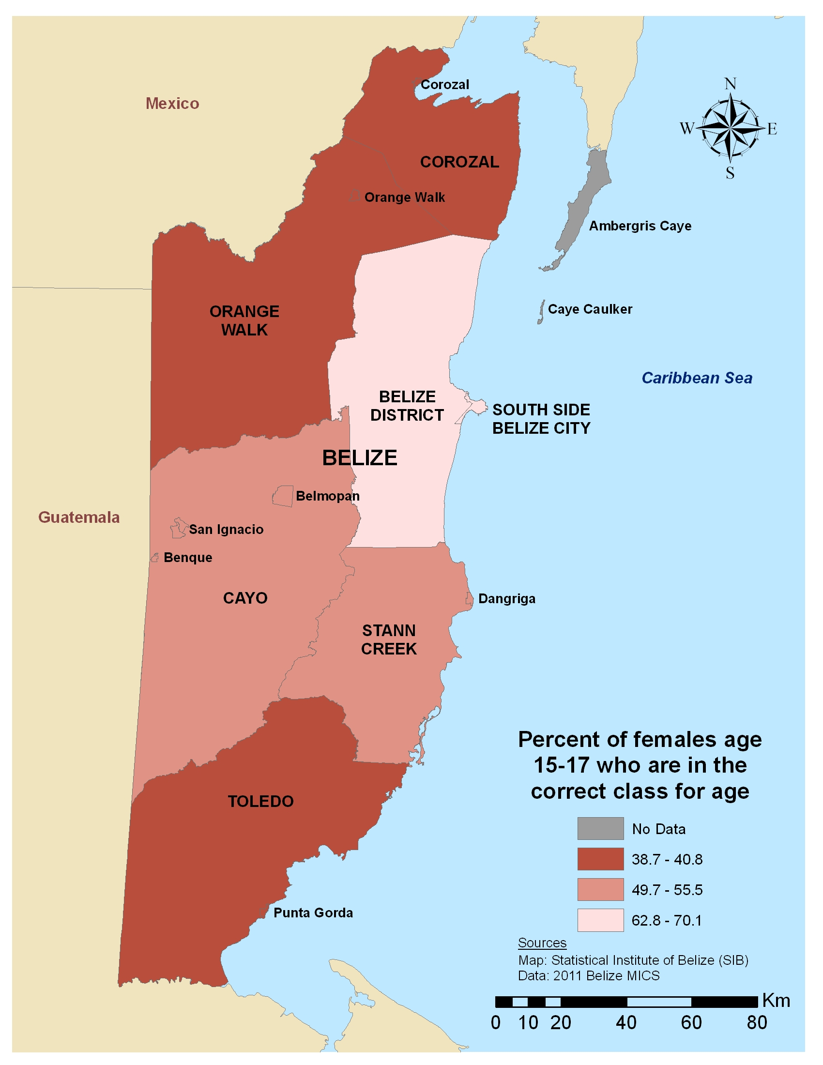
Figure 13: Percent of males and females age 15-17 who repeated last year's class in the current school year, by sex and district

Figure 14: Percent of females age 15-17 who repeated last year’s class in the current school year, by district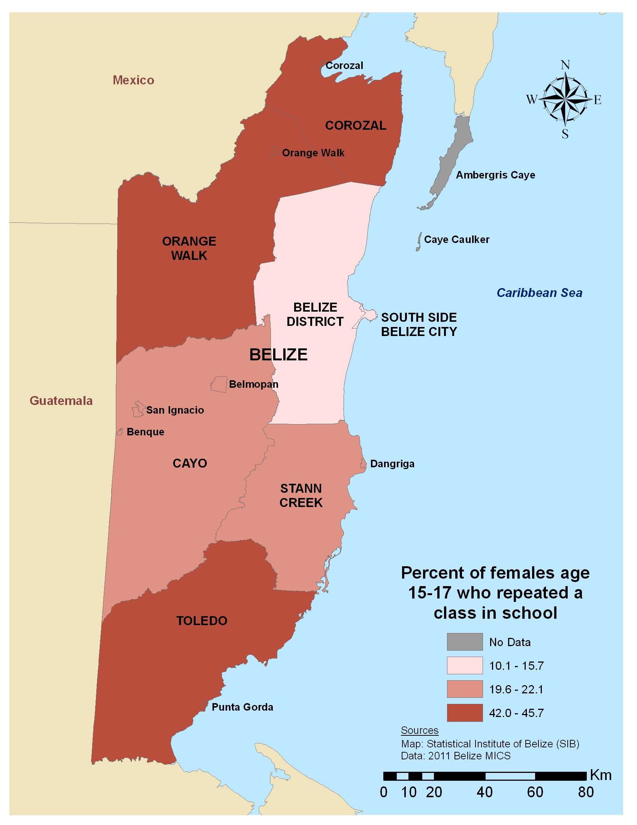
Figure 15: Percent of males and females age 15-17 who repeated last year's class in the current school year, by sex and ethnicity of household head

Literacy
Literacy, simply measured as one’s ability to read and write, is one of the clearest indicators for an individual’s overall societal standing and empowerment. Closely linked to school attendance and educational attainment – not to mention school quality – literacy may determine one’s capacity for upward mobility and success in the labor force, as well as ease of navigating everyday circumstances and decision-making. Data on literacy rates among adolescents offer a perspective on their level of preparedness for successful advancement through the educational system and beyond. Literacy data are also an important input into the planning and design of programs and services since many initiatives include messages and information in the printed media.
There are strong correlations between limited schooling (of which literacy in an indicator) and early marriage. Age at first birth, overall fertility and level of unmet need for contraception and reproductive health services also fluctuate significantly in most settings by the level of girls’ education. Districts demonstrating high levels of secondary school attendance are also more likely to have higher concentrations of health services available to older adolescent girls. In regions with high rates of illiteracy among adolescent populations, such as Corozal and Stann Creek, educational planners must consider how to reach these youth with effective programming around HIV and STI prevention and contraception use, among other program areas.

Table 6: Literacy among females age 15-19, by district, ethnicity of household head and area of residence
 | District | Illiterate | Literate | Secondary¹ | Other²
 | Corozal | 3.9 | 37.7 | 50.5 | 7.9
 | Orange Walk | 2.0 | 27.3 | 56.8 | 13.9
 | Belize | 0.0 | 10.8 | 89.2 | 0.0
 | Cayo | 1.7 | 24.5 | 70.3 | 3.4
 | Stann Creek | 5.2 | 18.7 | 72.2 | 3.9
 | Toledo | 2.6 | 35.0 | 61.7 | 0.7
 | South Side Belize City | 0.0 | 4.1 | 95.9 | 0.0
 | Ethnicity of Household Head
 | Creole | 0.8 | 9.6 | 89.6 | 0.0
 | Mestizo | 2.4 | 26.7 | 67.1 | 3.8
 | Garifuna | (0.0) | (3.6) | (96.4) | (0.0)
 | Maya | 3.1 | 47.1 | 48.1 | 1.8
 | Other | 2.5 | 7.7 | 62.3 | 27.5
 | Residence
 | Urban | 1.1 | 10.5 | 87.5 | 1.3
 | Rural | 2.6 | 32.4 | 57.8 | 7.1
 | Total | 1.9 | 22.3 | 71.3 | 4.5
¹Those young people who reached secondary school, regardless of whether or not they finished, were considered literate for the purposes of the Belize MICS4 and were not given the literacy test.
²"Other" includes missing, visually impaired and no sentence in required language.
Numbers in parentheses based on fewer than 50 cases

Time Use
The UN Convention on the Rights of the Child recognizes the rights of children and seeks to protect them from hazardous work, work that interferes with their education and work that is harmful to their health and physical and social development, among others. In many societies, very young children engage in petty trading in markets or on the streets while older youth are involved in the informal sector. In both scenarios, there are few, if any, protective measures in place to protect them and minimize exposure to dangerous conditions, exploitation or violence. Weak economic conditions and limited opportunities in the formal labor market, coupled with conditions of poverty, force young people, even those below the legal age, to seek out work and opportunities at the expense of education, social interactions with friends and other developmentally important experiences.
Within the household, young people often take on enormous levels of responsibility to help manage the daily affairs of the family. This may include caring for children or sick relatives, cooking, cleaning, collecting firewood or fuel and fetching water. The level of responsibility and the types of chores assigned to young people are often dictated by gender norms and other social values that can disproportionately affect girls or boys. Girls may be expected to take on the heavy burdens of caring for the household while boys may be required to engage in activities outside of the household. In either case, the amount of time spent on this work can significantly impact their pursuits towards education, employment or civic participation.
In general, girls tend to be employed at lower rates than boys, yet are often expected to assist more with unpaid household duties and community-related activities. It is imperative that policy-makers, program planners and other stakeholders have a clear understanding of the ways girls and boys utilize their time throughout the day – often in very different ways – and that this will influence their ability to participate in programs and seek out social or health services. It is important, therefore, to work to ensure equitable access to information, including on employment opportunities, for girls and boys, and to educate their parents, guardians and the community at large on the importance of finding a balance between their household and work responsibilities with that of their education so that young people’s schooling does not suffer.

Table 7: Percent of males and females age 10-14 who worked in past week for someone who is not a household member, by age, sex, district, ethnicity of household head and area of residence
 |  | Females 10-12 |  | Females 13-14 |  | Males 10-12 |  | Males 13-14
 | District | Paid | Unpaid | Paid | Unpaid | Paid | Unpaid | Paid | Unpaid
 | Corozal | 6.1 | 2.9 | 11.5 | 1.7 | 10.8 | 2.8 | 16.6 | 5.5
 | Orange Walk | 0.0 | 1.1 | 3.4 | 0.0 | 3.3 | 1.0 | 5.0 | 0.0
 | Belize | 0.0 | 0.0 | 0.0 | 0.0 | 0.0 | 5.1 | 11.8 | 2.5
 | Cayo | 1.8 | 2.8 | 6.1 | 3.1 | 5.5 | 2.2 | 8.9 | 3.5
 | Stann Creek | 0.0 | 2.8 | 5.7 | 1.9 | 6.1 | 1.0 | 16.5 | 0.0
 | Toledo | 1.7 | 2.6 | 1.3 | 1.3 | 1.7 | 0.8 | 2.8 | 4.6
 | South Side Belize City | 3.5 | 1.1 | 4.0 | 2.1 | 6.5 | 0.0 | 11.7 | 0.0
 | Ethnicity of Household Head
 | Creole | 0.5 | 2.3 | 5.8 | 1.5 | 3.6 | 0.0 | 10.3 | 1.8
 | Mestizo | 1.7 | 1.7 | 4.0 | 1.3 | 6.0 | 3.6 | 11.2 | 2.4
 | Garifuna | (0.0) | (0.0) | (0.0) | (4.3) | (2.2) | (0.0) | (19.0) | (0.0)
 | Maya | 3.9 | 2.3 | 1.3 | 1.3 | 4.9 | 0.8 | 5.0 | 2.9
 | Other | (3.3) | (1.0) | (10.6) | (2.2) | (0.0) | (0.0) | (11.6) | (5.4)
 | Residence
 | Urban | 1.8 | 1.2 | 3.9 | 2.3 | 3.6 | 2.2 | 8.3 | 1.4
 | Rural | 1.9 | 2.4 | 5.1 | 1.2 | 5.7 | 1.8 | 11.9 | 3.2
 | Total | 1.9 | 1.9 | 4.7 | 1.6 | 4.9 | 1.9 | 10.5 | 2.5
Numbers in parentheses based on fewer than 50 cases

Table 8: Percent of males and females age 10-14 who worked in past week to collect firewood or fetch water, by age, sex, district, ethnicity of household head and area of residence
 |  | Females |  | Males
 | District | 10-12 | 13-14 | 10-12 | 13-14
 | Corozal | 16.2 | 12.8 | 26.4 | 35.2
 | Orange Walk | 4.6 | 9.8 | 10.7 | 17.9
 | Belize | 0.0 | 0.0 | 1.8 | 7.4
 | Cayo | 12.1 | 10.0 | 21.1 | 35.4
 | Stann Creek | 6.9 | 14.2 | 20.2 | 32.0
 | Toledo | 12.7 | 17.4 | 38.1 | 50.0
 | South Side Belize City | 6.8 | 0.0 | 4.0 | 2.3
 | Ethnicity of Household Head
 | Creole | 2.3 | 3.7 | 6.2 | 11.3
 | Mestizo | 10.0 | 8.2 | 20.1 | 28.7
 | Garifuna | 0.0 | 8.2 | 4.4 | 5.2
 | Maya | 21.1 | 26.4 | 41.5 | 64.7
 | Other | 7.6 | 4.9 | 6.9 | 12.6
 | Residence
 | Urban | 2.9 | 2.5 | 5.2 | 7.3
 | Rural | 12.8 | 13.0 | 25.2 | 38.1
 | Total | 8.7 | 9.0 | 17.5 | 25.9

Table 9: Percent of males and females age 10-14 who engaged in other paid or unpaid family work, by age, sex, district, ethnicity of household head and area of residence
 |  | Females |  | Males
 | District | 10-12 | 13-14 | 10-12 | 13-14
 | Corozal | 12.1 | 9.8 | 8.6 | 11.2
 | Orange Walk | 3.6 | 4.1 | 4.0 | 7.3
 | Belize | 0.0 | 0.0 | 1.7 | 6.6
 | Cayo | 4.6 | 4.3 | 9.8 | 13.7
 | Stann Creek | 6.7 | 20.7 | 11.4 | 18.6
 | Toledo | 2.5 | 3.7 | 2.5 | 6.2
 | South Side Belize City | 1.1 | 0.0 | 0.0 | 4.5
 | Ethnicity of Household Head
 | Creole | 1.9 | 4.7 | 1.7 | 7.8
 | Mestizo | 5.3 | 7.2 | 6.7 | 10.6
 | Garifuna | 0.0 | 0.0 | 8.9 | 16.6
 | Maya | 5.2 | 1.1 | 5.5 | 11.4
 | Other | 6.7 | 7.3 | 7.1 | 9.4
 | Residence
 | Urban | 1.6 | 4.1 | 2.7 | 7.9
 | Rural | 6.2 | 6.4 | 7.9 | 11.4
 | Total | 4.3 | 5.5 | 5.9 | 10.0

Marriage and Relationships
Marriage can be a celebrated milestone for young people, one that signals a phase of shared resource acquisition and mutual benefit; although, in reality the benefits may not be equal for females and males. In some settings a marital union is the most socially acceptable context for which to start and support a family. Analyzing marriage rates, alongside rates of cohabitation, sheds light on the lived reality of girls. Legal marriage, common law marriage or an extended domestic partnership can provide access to an extended social network.
Poverty, economic opportunity and actualization of gender roles and rights are undoubtedly linked to marital status. For younger married girls, marriage may limit employment and educational pursuits outside the home due to the competing responsibilities related to the upkeep of the household and her spouse’s expectations. How these responsibilities are balanced – or imposed – get to the heart of how gender norms play out in her marriage. Married life, or living together with a boyfriend, may present related challenges inside the relationship for negotiating contraception use, equal decision-making power and other aspects of partnership. Very young brides face a host of challenges that limit their ability to control their health and wellbeing. In some settings, child brides often experience a sudden shrinking of their familial support systems and may lack control of resources, mobility and power, both in the context of their new homes and in their newly sanctioned intimate relationships.
More research should be done to differentiate how cohabitating, as opposed to marriage at a young age, may offer unique protections against some of the documented negative consequences of early marriage. Because early marriage almost always comes hand in hand with childbearing at a very young age, often before females are physiologically or psychologically ready, it will be important for policy-makers and program designers to note if girls in cohabitating situations delay having their first child at a higher rate than those who officially marry.
Table 10: Percent of females age 15-19 currently married and cohabitating and percent ever married, by age, district, ethnicity of household head and area of residence
 |  | Females 15-17 |  |  |  | Females 18-19
 | District | Currently married | Currently cohabitating | Ever married* |  | Currently married | Currently cohabitating | Ever married*
 | Corozal | 1.4 | 3.8 | 10.4 |  | 11.6 | 23.9 | 43.5
 | Orange Walk | 0.0 | 7.0 | 7.0 |  | 4.0 | 24.4 | 32.6
 | Belize | 0.0 | 6.2 | 6.2 |  | (4.6) | (13.4) | (26.2)
 | Cayo | 1.5 | 5.1 | 6.6 |  | (8.7) | (27.0) | (35.6)
 | Stann Creek | 1.8 | 11.4 | 14.8 |  | (2.8) | (23.0) | (29.2)
 | Toledo | 2.3 | 10.8 | 15.4 |  | 12.3 | 16.0 | 31.7
 | South Side Belize City | 0.0 | 2.6 | 2.6 |  | (0.0) | (15.6) | (18.4)
 | Ethnicity of Household Head
 | Creole | 0.0 | 2.1 | 2.9 |  | 0.0 | 16.8 | 22.2
 | Mestizo | 1.4 | 7.0 | 9.7 |  | 7.2 | 28.4 | 40.0
 | Garifuna | (0.0) | (3.3) | (3.3) |  | (0.0) | (6.0) | (16.6)
 | Maya | 1.8 | 13.8 | 17.3 |  | 21.7 | 9.3 | 32.5
 | Other | (0.0) | (4.0) | (4.0) |  | (5.7) | (9.1) | (14.8)
 | Residence
 | Urban | 1.2 | 4.4 | 6.0 |  | 4.1 | 14.7 | 24.9
 | Rural | 0.8 | 7.8 | 10.2 |  | 8.1 | 25.9 | 36.8
 | Total | 1.0 | 6.3 | 8.2 |  | 6.3 | 20.9 | 31.4
*Includes currently married or cohabitating and formerly married/in union
Numbers in parentheses are based on fewer than 50 unweighted cases

As presented in Table 10, some districts, such as Stann Creek and Toledo, show higher levels of both cohabitation and girls reported having ever been married compared with other districts among females age 15-17; this may mean that cohabitating carries the same cultural significance and acceptance as traditional marriage. Cohabitation in these districts may also be viewed as a transition into marriage. Cultural attitudes and an acceptance of cohabitation – perhaps as the most responsible arrangement given economic realities of young couples – are likely at play in areas where cohabitation and marriage rates are higher than in other areas. As noted before, it will be crucial to know exactly how the young people inside them view these arrangements to implement smart policies aimed at affecting gender empowerment and economic stability.
Figure 16: Percent of females age 15-19 who are currently married or cohabitating, by age and area of residence

As shown in Figure 16, marriage among girls in Belize occurs more often in rural areas, which may be due to the limited opportunities there for employment and education. However, the year between the 17th and 18th birthdays is a critical time for girls in both rural and urban locales. Age 18 marks a consistent rise in marriage for girls everywhere, but girls living in urban areas seem to enjoy a plateau of low marriage rates until then, while rural girls are marrying at steadily increasing rates starting at age 17. This may be an important transitional time for many girls, as they may be completing a level of study or transitioning into working adulthood. As the data demonstrate, there is a clear and tight window of time in which a girl’s life may change drastically. Program planners should consider how to target girls before they approach this milestone, and begin the conversations sooner regarding the decisions they are making and opportunities available during this important time.

Table 11: Percent of females age 15-24 married by certain age 15, by age 18, and median age at first marriage, by age, district, ethnicity of household head and area of residence
 | District | Percent married by age 15 (15-24) | Percent married by age 18 (18-24) | Median age at first marriage (15-24)
 | Corozal | 2.6 | 29.9 | 17
 | Orange Walk | 2.0 | 24.7 | 18
 | Belize | 1.2 | 18.6 | 18
 | Cayo | 1.8 | 27.1 | 17
 | Stann Creek | 4.5 | 28.4 | 17
 | Toledo | 3.4 | 31.4 | 16
 | South Side Belize City | 1.8 | 19.0 | 18
 | Ethnicity of Household Head
 | Creole | 1.0 | 17.2 | 18
 | Mestizo | 3.0 | 29.6 | 17
 | Garifuna | 1.8 | 20.3 | 18
 | Maya | 3.0 | 31.0 | 17
 | Other | 0.0 | 15.3 | 19
 | Residence
 | Urban | 1.3 | 20.9 | 18
 | Rural | 3.1 | 28.5 | 17
 | Total | 2.3 | 25.0 | 17

As demonstrated in Table 11, it is encouraging that there is a relatively low incidence of child marriage in Belize, with little variation among districts outside of Belize district. Mestizo and Mayan girls are more likely to be married before age 18 than girls from other ethnic groups.
Child marriage, often justified by cultural prescriptions and generational norms, is a broader issue that carries drastic power imbalances undermining a young woman’s ability to plan and space births, and protect herself from sexually transmitted disease. The conversation about marriage and cohabitation among young adults, even if rates of very young child marriage are low, needs to be taken in context with other key reproductive health outcomes.

Childbearing
Parenthood and timing of childbearing among young people is particularly important because of the effects it has on the sexual and reproductive health and wellbeing of the mother and child. Young, first-time mothers are at very high risk for maternal and infant mortality due to the physiological limits of their bodies and the poor social and economic circumstances that often accompany early childbirth in low resource settings. Fertility also has an impact on a female’s status in society and her ability to study and work; the responsibilities of childbearing can force a young girl to leave school before graduating with little hope of returning. Given that infant and maternal mortality rates decrease with age, analyzing childbirth trends among the young population and its relationship to other outcomes is critically important to addressing the needs of youth and adolescents.
The consequences of childbearing on a female’s health, education outcomes and labor force participation necessitate evidence-based policy and programmatic responses to effectively mitigate their impact on the lives of the mother and her children. It behooves program planners concentrating on the youngest first-time mothers and first-time parents to integrate HIV and STI testing and prevention messages, along with child wellness information, to ensure young females are healthy and safe.
Table 12: Percent of females age 15-24 who have ever given birth to a child, median age at first birth and teen childbearing, by age, district, ethnicity of household head and area of residence
 | District | Females (15-17) | Females (18-19) |  | Median age at first birth (15-24) | Percent who had a child before age 18 (18-24)
 | Corozal | 6.4 | 23.6 |  | 18 | 14.0
 | Orange Walk | 1.2 | 26.6 |  | 18 | 17.7
 | Belize | 3.9 | (17.0) |  | 18 | 11.7
 | Cayo | 3.5 | (20.7) |  | 19 | 12.8
 | Stann Creek | 6.5 | (23.1) |  | 18 | 21.7
 | Toledo | 11.0 | 24.8 |  | 17 | 22.7
 | South Side Belize City | 4.2 | (15.4) |  | 19 | 13.7
 | Ethnicity of Household Head
 | Creole | 6.1 | 14.0 |  | 19 | 11.1
 | Mestizo | 3.3 | 27.2 |  | 18 | 18.5
 | Garifuna | 3.4 | (10.6) |  | 18 | 9.4
 | Maya | 9.9 | 27.7 |  | 18 | 18.0
 | Other | 3.9 | (6.9) |  | 19 | 9.9
 | Residence
 | Urban | 2.1 | 14.8 |  | 18 | 12.0
 | Rural | 7.0 | 26.8 |  | 18 | 18.5
 | Total | 4.8 | 21.5 |  | 18 | 15.5
Numbers in parentheses based on fewer than 50 cases

Figure 17: Percent of females age 15-19 who have ever given birth, by age and area of residence

Table 13: Childbearing status among females age 15-19, by different indicators
 |  | Females 15-17 |  |  | Females 18-19
 | Characteristics | Never gave birth | Ever gave birth |  | Never gave birth | Ever gave birth
 | Highest Education Level
 | Primary | 88.3 | 11.7 |  | 53.6 | 46.4
 | Secondary | 97.8 | 2.2 |  | 82.5 | 17.5
 | Higher | (92.1) | (7.9) |  | 94.8 | 5.2
 | Marital Status
 | Never married | 97.9 | 2.1 |  | 96.6 | 3.4
 | Ever married | 65.5 | 34.5 |  | 39.2 | 60.8
 | Wealth Quintile
 | Poorest | 92.8 | 7.2 |  | 67.6 | 32.4
 | Second | 93.3 | 6.7 |  | 70.1 | 29.9
 | Third | 97.2 | 2.8 |  | 79.9 | 20.1
 | Fourth | 96.4 | 3.6 |  | 86.8 | 13.2
 | Wealthiest | 96.3 | 3.7 |  | 87.6 | 12.4
Numbers in parentheses based on fewer than 50 cases

Table 14: Childbearing status among females age 20-24, by different indicators
 |  | Females 20-22 |  |  | Females 23-24
 | Characteristics | Never gave birth | Ever gave birth |  | Never gave birth | Ever gave birth
 | Highest Education Level
 | Primary | 34.9 | 65.1 |  | 19.3 | 80.7
 | Secondary | 49.5 | 50.5 |  | 27.9 | 72.1
 | Associates | 77.4 | 22.6 |  | 46.8 | 52.0
 | Bachelors + | (87.3) | (12.7) |  | (93.2) | (6.8)
 | Marital Status
 | Never married | 90.6 | 9.4 |  | 70.5 | 29.5
 | Ever married | 25.3 | 74.7 |  | 14.5 | 85.5
 | Wealth Quintile
 | Poorest | 37.5 | 62.5 |  | 16.1 | 83.9
 | Second | 44.9 | 55.1 |  | 19.9 | 80.1
 | Third | 58.9 | 41.1 |  | 32.8 | 67.2
 | Fourth | 58.7 | 41.3 |  | 40.8 | 59.2
 | Wealthiest | 71.5 | 28.5 |  | (50.2) | (49.8)
Numbers in parentheses based on fewer than 50 cases

In-country data suggest that marriage is the consistent and reliable context in which young women first have children. For girls in Belize age 15 and older, there is an inverse relationship between never being married and childbearing, which may suggest that young girls are reluctant to have their first child outside of marriage. For girls cohabitating or in common law marriages, more in-depth research needs to be conducted to understand if this translates into more sexual negotiation, increased contraception use or a shift in gender norms that may be the result of more accepting cultural standards around living together outside of marriage. Wealth and higher educational attainment are also protective factors against childbearing in Belize, an expected expression of the interconnectedness between poverty, education and fertility.
Garifuna girls, along with other ethnicities not specified, have nearly half the rates of fertility at age 18 than Mestizo and Mayan household ethnicities, which is an important flashpoint in the data for policy-makers and health service professionals working among the different ethnic groups. Documented fertility trends on young people and how they vary geographically and between ethnic groups is essential to establishing programs required to delay childbirth and support expecting parents for maximum safety and security through the entry into parenthood.

Sexual Behavior
Though a rising share of sexual relations, including sexual initiation, is taking place outside of marriage, in most countries the majority of adolescent girls’ sexual activity takes place within marriage. However, marriage is not a guarantee that sexual relations are safe, voluntary, or pleasurable. In some settings, married girls have a higher risk for sexually transmitted infections and HIV than their unmarried, sexually active peers, given the large age differential between the married girls and their husbands/partners. Married and unmarried sexually active adolescents need information, social support for informed decision-making and access to services and technologies to effectively maintain their sexual and reproductive health. In order to develop meaningful programs, it is vital to understand the nature of the partnerships and the context of these relationships. Although there is an overlap of needs, sexually active unmarried and married girls often require different services to ensure safe reproductive health due to their very different circumstances.
For both girls and boys, exploring their sexuality and initiating sexual behavior takes place in the context of gender norms and external pressures from family and peers. Such norms play a significant part in determining what information they receive and their access to services as well as whether sexual activity takes place within or outside of marriage. Additionally, restrictive gender norms and limited opportunity also play a part in young women engaging in transactional sexual relations, in addition to unprotected or nonconsensual sexual. Early sexual initiation, particularly before the age of 15 or the official age of consent is not only illegal but also dangerous for girls given their vulnerability and physical immaturity. The risks are compounded when the girls have limited or no information or knowledge on how to maintain safe and healthy reproductive and sexual health. And while the proportion of girls who have sex at such an early age may be small, those that do need specialized support to ensure the sexual relations do not result in irreversible and life-threatening situations, such as pregnancy and HIV.

Table 15: Percent of females age 15-24 who have had sex by age 15, by age, district, ethnicity of household head and area of residence
 | District | Females (15-19) | Females (20-24)
 | Corozal | 3.9 | 4.0
 | Orange Walk | 4.3 | 6.1
 | Belize | 5.5 | 7.0
 | Cayo | 2.6 | 3.9
 | Stann Creek | 7.7 | 11.9
 | Toledo | 0.0 | 7.9
 | South Side Belize City | 4.2 | 8.1
 | Ethnicity of Household Head
 | Creole | 5.3 | 5.3
 | Mestizo | 4.0 | 5.9
 | Garifuna | (4.0) | 14.0
 | Maya | 0.9 | 6.6
 | Other | 4.9 | (9.7)
 | Residence
 | Urban | 3.3 | 6.9
 | Rural | 4.5 | 6.3
 | Total | 3.9 | 6.6
Numbers in parentheses based on fewer than 50 cases

Antenatal Care & Delivery Assistance
Women in developing countries are at-risk of many pregnancy- and childbirth-related complications. These include, inter alia, hemorrhage, obstructed labor, preeclampsia, anemia and infection. Ensuring the availability of antenatal, labor and delivery and postpartum care is essential for reducing maternal and infant mortality and related reproductive health risks. This is especially true for mothers in rural settings who may experience a dearth of service options, impoverished women with serious obstacles to accessing available services and for young, first-time mothers whose physiological immaturity may compromise her and her newborn’s health and safety. While provisions for antenatal care are unquestionably important, policy-makers and other stakeholders need to pair such provisions with investments in programs and services aimed at helping non-pregnant young girls avoid early childbirth before it’s too late. First-time mothers who are more empowered and have greater control over their resources are more likely to obtain antenatal care and seek the assistance of a professional during delivery than very young child brides who are pregnant for the first time and have little to no knowledge of their options. In many instances, dual investments in preventing child marriage and expanding reproductive care will help break the cycle of intergenerational poverty, in addition to reducing rates of maternal and child mortality.
Table 16: Percent of females age 15-24 who gave birth in the last two years whose birth was attended by a professional* and percent of females who gave birth in the last two years who had at least 4 ANC visits by any type of provider, by age, district, ethnicity of household head and area of residence
 |  | Birth attended by a professional* |  |  | At least 4 ANC visits with any provider
 | District | Females (15-19) | Females (20-24) |  | Females (15-19) | Females (20-24)
 | Corozal | 100.0 | 100.0 |  | 93.6 | 91.0
 | Orange Walk | 100.0 | 100.0 |  | 87.2 | 86.2
 | Belize | 76.4 | 93.1 |  | 100.0 | 100.0
 | Cayo | 100.0 | 100.0 |  | 91.3 | 93.6
 | Stann Creek | 100.0 | 100.0 |  | 89.7 | 100.0
 | Toledo | 90.9 | 100.0 |  | 90.3 | 93.9
 | South Side Belize City | 100.0 | 93.9 |  | 100.0 | 91.3
 | Ethnicity of Household Head
 | Creole | 100.0 | 94.1 |  | 94.1 | 94.3
 | Mestizo | 98.8 | 99.2 |  | 96.0 | 95.3
 | Garifuna | (33.2) | 100.0 |  | (100.0) | 100.0
 | Maya | 96.4 | 100.0 |  | 76.3 | 89.3
 | Other | 100.0 | (100.0) |  | 100.0 | (71.9)
 | Residence
 | Urban | 91.2 | 97.9 |  | 95.5 | 96.0
 | Rural | 98.1 | 98.8 |  | 91.2 | 90.2
 | Total | 96.3 | 98.4 |  | 92.3 | 92.7
*A professional is a doctor, nurse, midwife or auxilary midwife
Numbers in parentheses based on fewer than 50 cases

Antenatal care and delivery assistance for girls age 15-24 is very common in Belize across all districts and household ethnicities. Given that only one-third of younger Garifuna girls have a professional in attendance during childbirth, they may instead have given birth with traditional attendants or in ways more in line with other customs specific to their culture. The reach of influence of professionals in delivery care is sometimes thwarted by poor infrastructure, including lack of training and educational opportunities for medical professionals. Policy-makers and health planners in many developing countries have expanded the definition and scope of professionals for reproductive care to include paraprofessionals and more traditional midwifery techniques sometimes unsanctioned by western medicine. Perhaps for girls in rural areas of Belize, this may increase the safety of childbirth even in remote areas.

HIV Testing
Adolescents have very different exposure to HIV testing depending on their life circumstances. Young people attending school may receive HIV testing and counseling as part of a school-based outreach program, whereas those not in school will have to seek out the services for HIV and STI testing and counseling. Furthermore, girls married at a young age will most likely be without critical social support for receiving HIV testing, while her status as a young bride may put her at an elevated risk for HIV if her partner is considerably older and more experienced than she is. Contraception may not be an option at all in her relationship, which compounds her inability to protect herself from HIV infection. Testing programs and interventions certainly have their place but they are insufficient alone to curb the tide of HIV in most countries. Programmatic endeavors to expand HIV testing will be most successful when matched with interventions aimed to reduce child marriage, early pregnancy and low educational attainment.
Testing rates are fairly consistent at about one-quarter of girls in early adolescence (age 15-19) for all districts, except Toledo. HIV testing in Toledo is much less prevalent, even as girls in older cohorts get tested in much greater numbers in neighboring districts by the time they are between the ages of 20 and 24. Toledo could be experiencing such low numbers in HIV testing because of the lack of available services; more focused research and programmatic effort needs to be paid to this district in light of its stark differences to the rest of the country. While there remains a disparity between rural and urban rates of HIV testing, rates stay consistent between age cohorts. Marriage or sexual initiation around age 17 or 18 may prompt young women to receive either voluntary or compulsory HIV testing, and may account for this consistency, and HIV testing before or during pregnancy or at childbirth may account for the large differences seen between 15-19-year-olds and 20-24-year-olds.

Table 17: Percent of females age 15-24 who have ever been tested for HIV and percent of females who have ever been tested for HIV and received the results, by age, district, ethnicity of household head and area of residence
 |  | Ever tested for HIV |  |  | Ever tested for HIV and received the results
 | District | Females (15-19) | Females (20-24) |  | Females (15-19) | Females (20-24)
 | Corozal | 25.5 | 55.4 |  | 24.8 | 48.0
 | Orange Walk | 23.5 | 69.4 |  | 22.1 | 68.0
 | Belize | 25.3 | 67.5 |  | 25.3 | 67.5
 | Cayo | 24.1 | 64.0 |  | 21.7 | 60.9
 | Stann Creek | 28.6 | 75.5 |  | 27.6 | 71.9
 | Toledo | 9.5 | 36.5 |  | 8.7 | 34.2
 | South Side Belize City | 29.4 | 81.2 |  | 28.6 | 79.5
 | Ethnicity of Household Head
 | Creole | 28.6 | 79.6 |  | 28.6 | 78.6
 | Mestizo | 26.1 | 63.1 |  | 24.6 | 59.5
 | Garifuna | (27.7) | 86.2 |  | (25.7) | 84.6
 | Maya | 14.3 | 43.4 |  | 13.7 | 39.4
 | Other | 11.6 | (41.8) |  | 9.2 | (41.8)
 | Residence
 | Urban | 25.0 | 72.6 |  | 24.7 | 71.7
 | Rural | 23.3 | 59.4 |  | 21.4 | 55.3
 | Total | 24.1 | 65.7 |  | 22.9 | 63.1
Numbers in parentheses based on fewer than 50 cases

Figure 18: Percent of females age 15-24 who ever had an HIV test and received the results, by district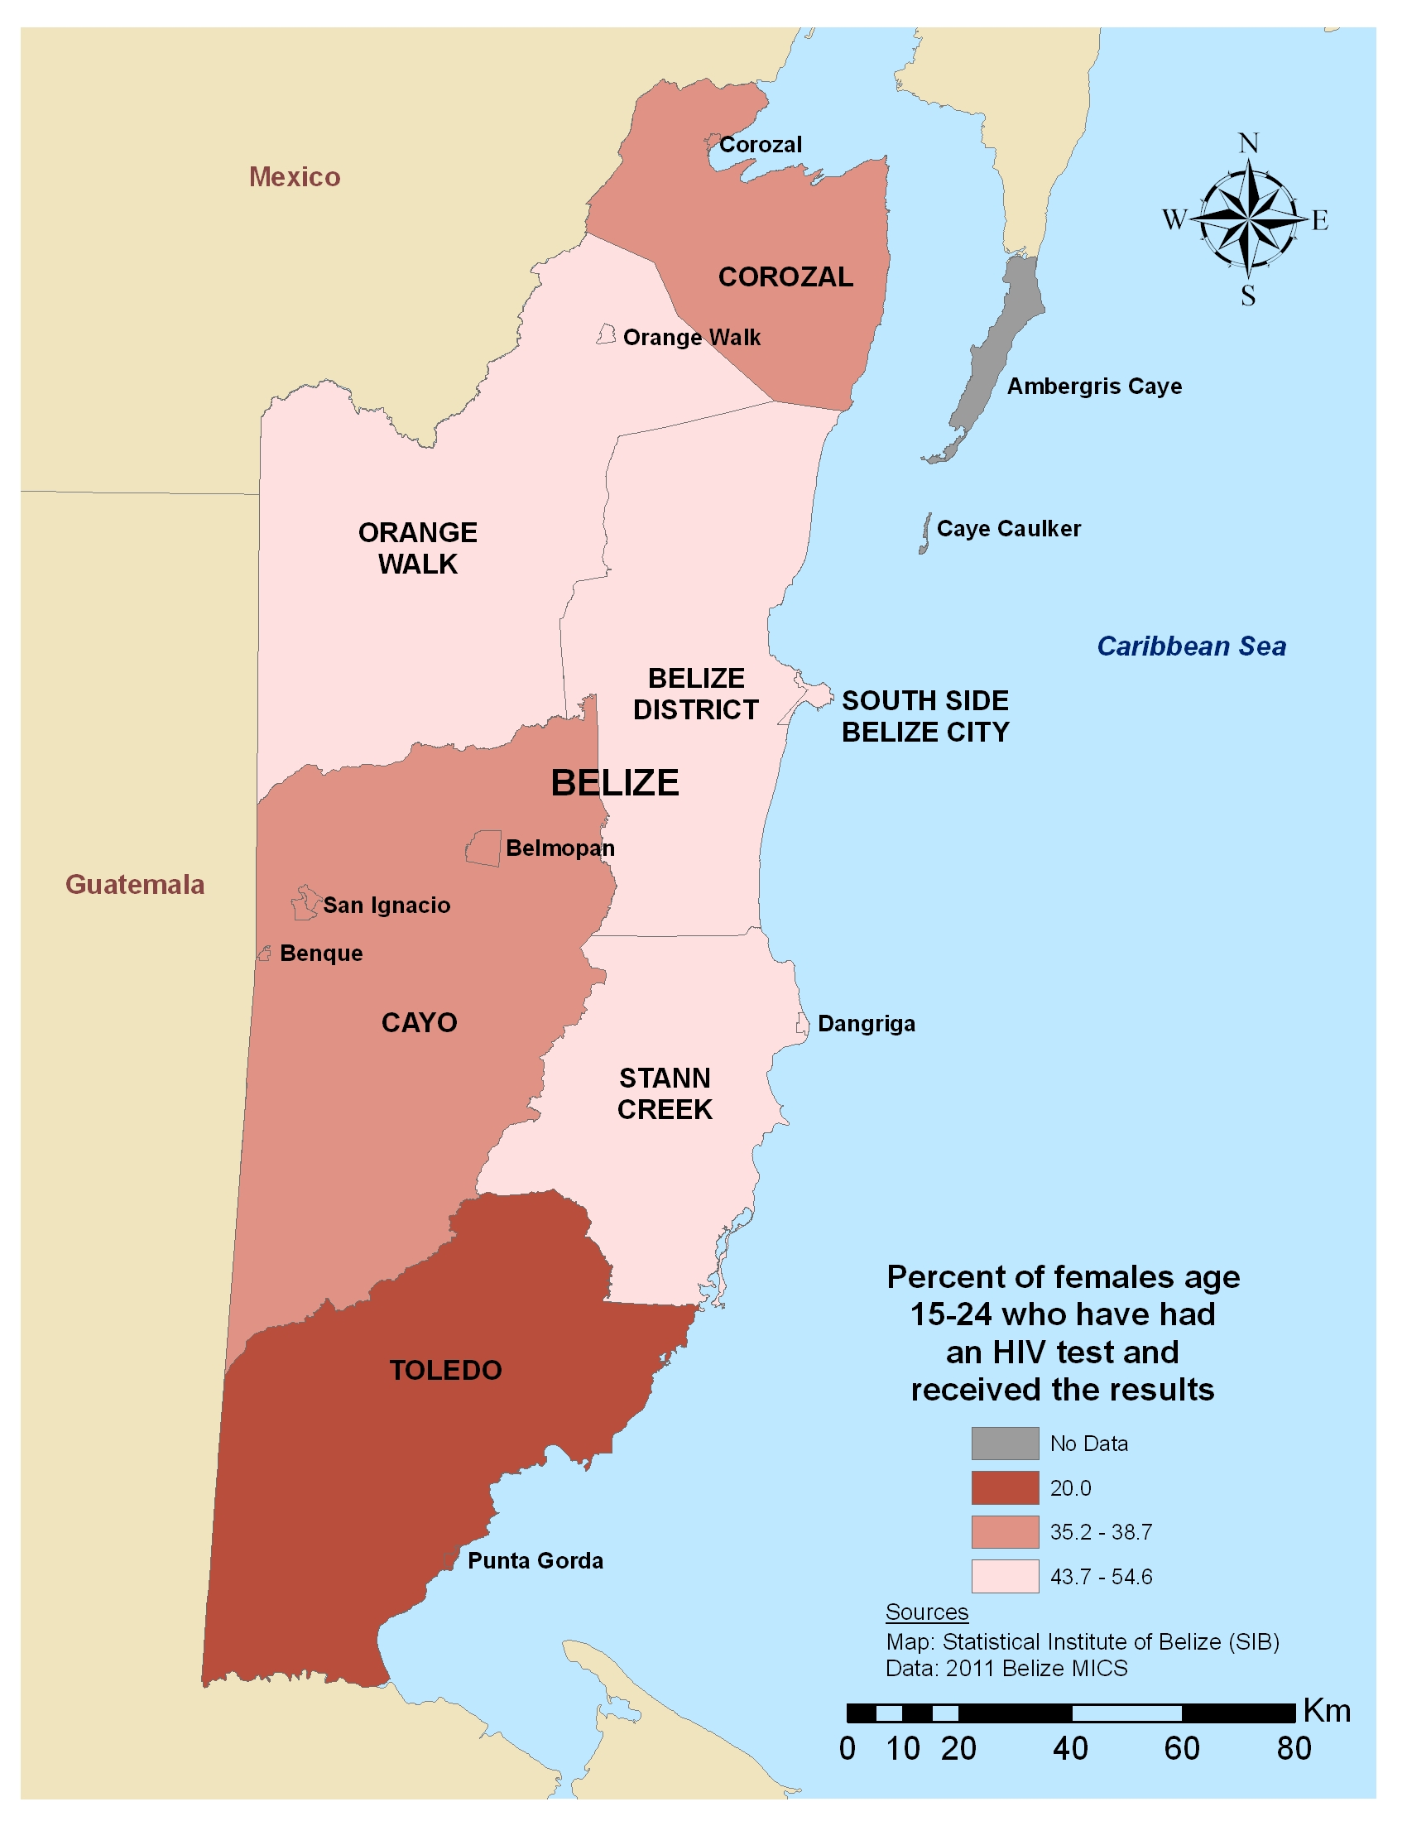

Attitudes Towards Domestic Violence
Violence against women in any form, at the hands of any perpetrator, is a violation of their human rights and, when pervasive, inhibits the social and economic growth and development of all societies. As young people begin to mature and commence their sexual life, they do so under the influence of the surrounding social context. Girls and boys often internalize these norms very early in life, laying a foundation for unequal sexual relations, social interactions and access to resources. Gender norms are often imposed and reinforced by previous generations and may only evolve with education and exposure to other ways of thinking. These norms affect males’ and females’ perceptions of the acceptability of using violence to control girls’ behavior, friendships, social interactions and mobility, as well as the circumstances, timing and safety of sexual relations.
There is a correlation between inequitable gender norms and the experience of gender or sexual-based violence; women who agreed that there are circumstances under which it is acceptable for a husband to beat his wife are more likely to report ever having experienced violence (UN Millennium Project 2006). It is therefore essential that data on the perceptions of males and females on the acceptability of domestic violence as well as actual experiences with violence, when possible, form the foundation of the decision-making landscape on the design of strategies to minimize the deleterious effects of violence on both individuals and society as a whole.
For both younger and older adolescents who have ever been married in Belize, there is a consistent higher acceptance and justification for domestic violence. This could be due to the tendency to justify behavior they have personally experienced. Marriage provides a more controlling context by which oppressive gender norms may be played out. In the districts and ethnic groups with high incidence of acceptance of domestic violence, there is cause for concern and need for immediate programmatic attention. In addition, more data collection would be useful on actual experiences of physical violence, both for married and cohabitating adolescent girls, to round out the picture of the prevalence of domestic violence and the attitudes surrounding it.

Table 18: Percent of females who feel that domestic violence is justifiable under certain circumstances, by age, district, ethnicity of household head and area of residence
 | District | Females (15-19) | Females (20-24)
 | Corozal | 28.4 | 17.9
 | Orange Walk | 13.6 | 13.0
 | Belize | 19.7 | 9.1
 | Cayo | 19.3 | 20.1
 | Stann Creek | 36.5 | 26.9
 | Toledo | 25.7 | 29.6
 | South Side Belize City | 16.2 | 12.0
 | Ethnicity of Household Head
 | Creole | 20.0 | 12.8
 | Mestizo | 20.1 | 15.8
 | Garifuna | 28.6 | 13.4
 | Maya | 27.8 | 41.1
 | Other | 19.8 | (9.3)
 | Residence
 | Urban | 17.4 | 10.4
 | Rural | 24.7 | 23.2
 | Total | 21.4 | 17.1
Numbers in parentheses based on fewer than 50 cases

Figure 19: Percent of females age 15-24 who feel that domestic violence is justifiable under certain circumstances, by district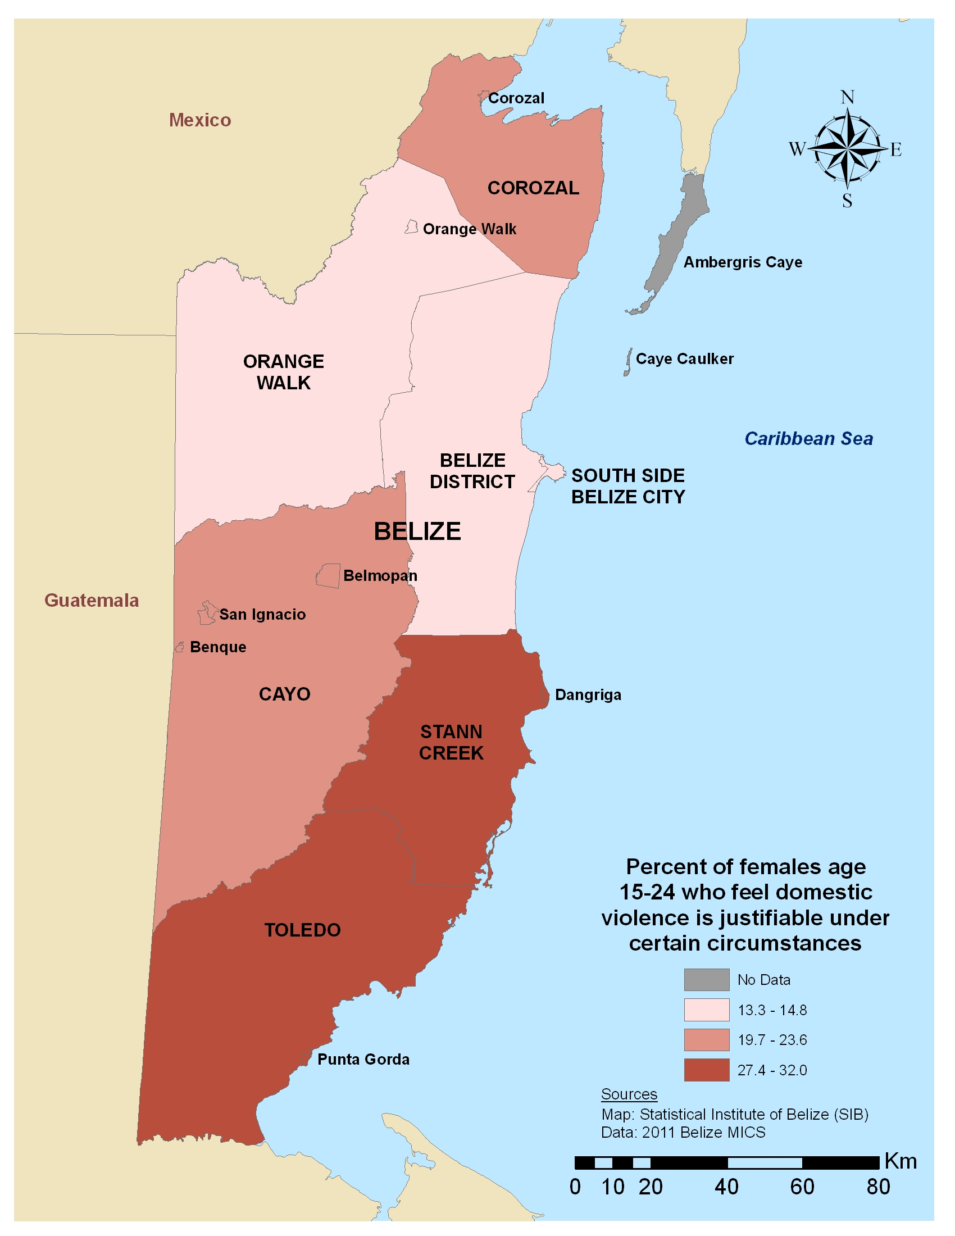
Table 19: Percent of females age 15-19 who feel domestic violence is justifiable under certain circumstances, by age and different characteristics
 |  | Females 15-17 |  |  | Females 18-19
 | Characteristics | Does not justify wife beating | Justifies wife beating |  | Does not justify wife beating | Justifies wife beating
 | Marital Status
 | Never married | 76.9 | 23.1 |  | 87.6 | 12.4
 | Ever married | 61.7 | 38.7 |  | 73.1 | 26.9
 | Wealth Quintile
 | Poorest | 68.0 | 32.0 |  | 76.3 | 23.7
 | Second | 73.3 | 26.7 |  | 83.0 | 17.0
 | Third | 76.8 | 23.2 |  | 84.6 | 15.4
 | Fourth | 78.9 | 21.1 |  | 85.3 | 14.7
 | Wealthiest | 80.9 | 19.1 |  | 85.8 | 14.2

Table 20: Percent of females age 20-24 who feel domestic violence is justifiable under certain circumstances, by age and different characteristics
 |  | Females 20-22 |  |  | Females 23-24
 | Characteristics | Does not justify wife beating | Justifies wife beating |  | Does not justify wife beating | Justifies wife beating
 | Marital Status
 | Never married | 87.3 | 12.7 |  | 88.3 | 11.7
 | Ever married | 83.8 | 16.2 |  | 74.9 | 25.1
 | Wealth Quintile
 | Poorest | 80.6 | 19.4 |  | 66.6 | 33.4
 | Second | 79.1 | 20.9 |  | 76.3 | 23.7
 | Third | 86.8 | 13.2 |  | 74.5 | 25.5
 | Fourth | 88.2 | 11.8 |  | 88.1 | 11.9
 | Wealthiest | 92.1 | 7.9 |  | 90.6 | (9.4)
Numbers in parentheses based on fewer than 50 cases

Section 4: Closing Remarks

Conclusions
The lives of young people are determined by a complex set of interactions between a host of social and demographic factors. The magnitude of these interactions is determined by factors both endogenous (e.g., sex, age or ethnic affiliation) and exogenous (e.g., social, political and economic environments or urban versus rural area of residence) to the young people themselves. No absolute conclusions can be made about the relationships between these factors, the direction of causality or how they impact each young person. Drawing these types of conclusions is not the purpose of this report as more in-depth and complex research would be necessary to begin answering the question. The purpose of this report is, however, to provide a solid base of evidence sufficient enough to motivate and encourage policy-makers, program planners and other stakeholders from government and civil society to thoroughly, strategically and creatively use the information to inform the decision-making process. In order to do this in an effective manner, there needs to be a high-level commitment originating from within the government to support the establishment of targeted, evidence-based policies and interventions for different subgroups of youth and adolescents with a focus on young girls in order to reach the most marginalized and at risk populations.
The data in this report represent one of many key inputs to evidence-based strategies to reach the most vulnerable young people with targeted policies and programs. Given that the selected indicators cover a wide range of contexts and scenarios, policy-makers and program designers from different sectors can begin to make the case for targeted investments directed at the needs of the most vulnerable, in particular girls. However, due to limitations in the MICS, the data are by no means exhaustive, nor do they cover all areas that may be necessary for local advocacy efforts. Country teams likely have access to additional sources of qualitative and quantitative data that may fill in the gaps as determined by the needs of these local actors. The effort to build a deep and broad evidence base on the lives and experiences of young people in an attempt to draw out the specific details of those living on the margins will be strengthened by a unified attempt to understand how these data are required to inform the development and measurement of national development goals and objectives.

Acknowledgements
This report with authored by Adam Weiner and Kelly Hallman on behalf of the Population Council. Various staff at UNICEF, UNFPA, UNAIDS and UNDP in Belize are acknowledged for their contributions to the production of the report. We are grateful to the Statistical Institute of Belize for sharing shape files that allowed the construction of the maps for this report.

