MICS4 fieldwork in progress in Kazakhstan in spite of harsh winter

The Multiple Indicator Cluster Survey-4 (MICS) is in full swing despite the winter conditions, which fortunately have not been that severe yet. The survey, which will cover about 16,000 households, will present updated and disaggregated data on many indicators concerning health, nutrition, education and protection of children, youth, men and women in Kazakhstan.
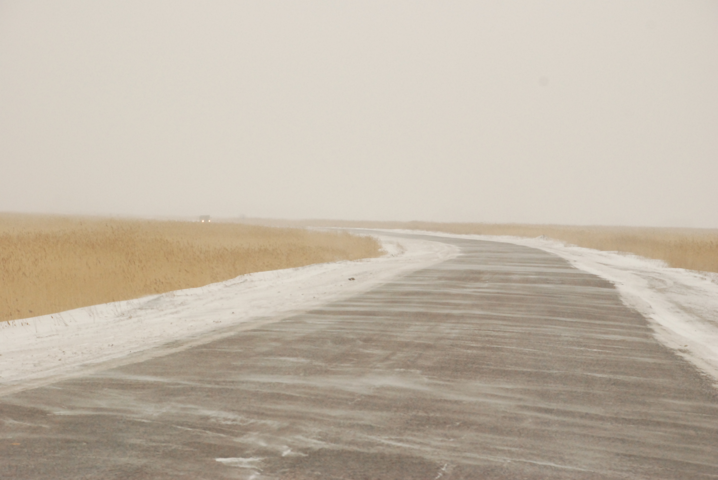
MICS4 fieldwork in Kazakhstan is challenged by the very low population density and country’s vast territory. Photo by Sultanbek Khudaibergenov, UNICEF Kazakhstan Communication Officer

This is the second MICS that is taking place in Kazakhstan. The first MICS took place in 2006. This MICS is unique because the Government of Kazakhstan has provided almost half of the funds for the survey. The MICS fieldwork in Kazakhstan is challenged by the very low population density and the country’s vast territory, most of which is affected by the severe and long winter.

The fieldwork, which started in early November 2010, is being implemented by 16 teams - one team per oblast (sub-national administrative unit in Kazakhstan). For many interviewers, this is the second MICS they participate in. Understanding the importance of the previous MICS for Kazakhstan, those interviewers are even more committed to get accurate information on the situation in the country.
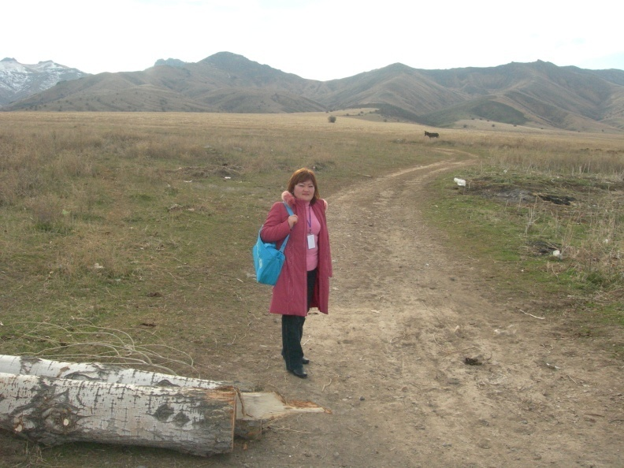
Very often interviewers have to travel long distances to get to the selected cluster; fortunately, winter conditions have not been very severe yet. An interviewer in Zhambyl Oblast is starting her day. Photo by Berik Atakhanov, measurer and interviewer of Zhambyl Oblast team

“I am sure that MICS which was conducted in 2006 did play an important role in the development of the public policies that are implemented now,” says Shargul Takhtarbekova, an interviewer in Almaty Oblast. “People have also changed since the last MICS. They understand the importance of such surveys in changing their lives, so they respond to questions more willingly.”

In rural areas support was provided by local governors (akims) to establish confidence among communities towards the team members, but also in some cases presents a good opportunity for households to bring up their problems with the governor’s office.

Unlike the rural areas, teams working in the urban areas such as Almaty, Astana and Taraz cities face difficulties in accessing households because of a lack of clear understanding from the population. “We have to try different strategies to be able to talk to the household head,” says Inga Shevtsova, the supervisor of the MICS data collection team in Zhambyl Oblast. ”If we are able to have the door opened, the rest goes smoothly,” she adds.
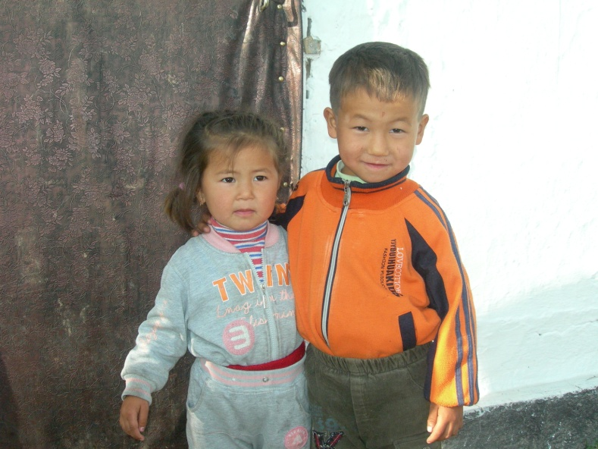
The family of these siblings in Zhambyl Oblast was selected randomly for participation in MICS4. There is a separate questionnaire in MICS for children under-five administered to mothers/primary caregivers. Photo by Berik Atakhanov, measurer and interviewer of Zhambyl Oblast team

The MICS team who were aware of scepticism towards surveyors in the urban areas planned and implemented a communication campaign that included using central and regional TV stations to broadcast a public service advertisement and giving interviews about MICS. Some of the team supervisors before and during the data collection organized local press conferences and made newspapers articles about the MICS data collection in their respective regions, explaining the importance of the survey.

“The preparation and implementation of MICS has been really challenging for us, giving the fact that last year we had the Census and we are still processing the Census data and producing relevant reports. But since the decision on MICS implementation in 2010 was made back in 2006 and the Government allocated funding to support MICS in Kazakhstan we had to start it this year. I am thankful to UNICEF for providing all kind of technical support as well as for providing funding for shortfalls we faced this year. We believe that the data and information collected will influence economic and political decisions of the local and national governments in our country,” says Gyulnara Kukanova, MICS4 coordinator in Kazakhstan.

Although weather has been favourable for the fieldwork, some selected areas are already out of reach. “We have been exploring ways to reach Dostyk District affected by the heavy snowfalls and have now found the exact route that will take us there despite the snow”, explains Svetlana Imirova, supervisor of the team in Almaty Oblast. The team will have to take train for 4-5 hours before walking to the selected enumeration area, but being fully aware of the importance of covering each household, they are fully determined to get to Dostyk before the end of the fieldwork. Shargul Tokhtarbekova, an interviewer in Almaty Oblast, says in the poem about MICS that thanks to teamwork all difficulties can be overcome.
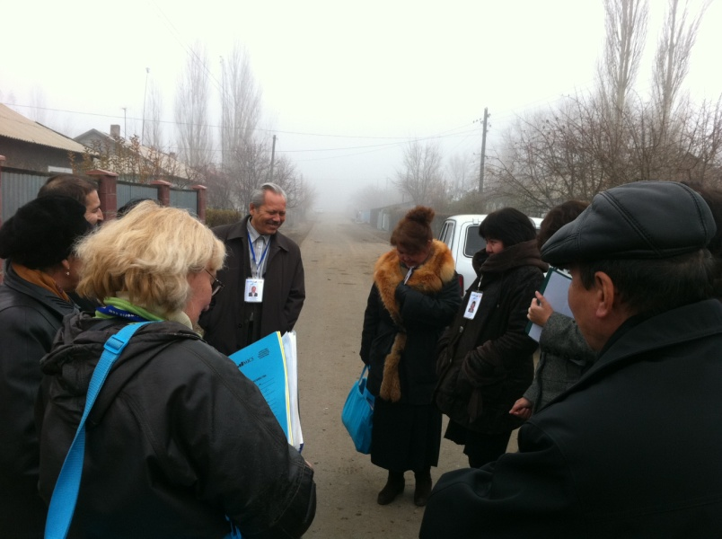
The MICS4 team in Almaty Oblast is starting interviews in a new cluster. Photo by Turgay Unalan

Оставляя километры за собой,
От одного аула мы движемся в другой.
В дом заходя очередной приветствуем:
«Здраствуйте, как мы живем?!»
В ответ мы слышим смех детей,
А зачастую слезы, боль несут о том
Что тяжелым грузом на душе лежит давно.
А выходя свечу надежды зажигаешь в нем!
Как в песенке известной нам поется:
«Надежда – мой компас земной,
А удача – награда за смелость,
А песни довольно одной!
Чтоб только о доме в ней пелось!»
И вечерами делясь о пережитом
Нас за столом усталость покидает
Ведь говорят когда все вместе – сила!
И нестрашна нам трудность никакая,
Ведь миссия у нас большая!
В доме каждом пробудить надежду, веру укрепить
И поселить любовь!!

Leaving miles and miles behind,
We are moving from one village to another
Entering the next household, we greet:
“Hello, how are you doing?”
And in response we hear children’s laugh,
Often tears, pain that tells us about
What heavy load they have
In their souls for years.
And when we leave we feel that a candle of hope was lit by us!
Just like in the well-known song:
“Hope is my compass,
And good fortune is the price for my courage,
And one song would be just enough,
If it says about a household!”
In the evenings, when we share about our experiences
The tiredness suddenly leaves us
It is true when people say
“When we are together – we are Power and Force!”
And we are not afraid of any problems and difficulties
Since our mission is Great!
In each household to light Hope and Strengthen Trust and Belief
And spread Love!!

